QUEENSLAND
WADER
Issue number 089 September, October and November 2014
Newsletter of the Queensland Wader Study Group (QWSG), a special interest group of
Birds Queensland Incorporated. www.waders.org.au

Yalu Jiang National Nature Reserve, China
by Arthur Keates

In issue 88 of Queensland Wader I reported on my visit to Chongming Dongtan National Nature Reserve, China in mid-April. Afterwards, I took part in the northern shorebird migration surveys at the Shuangtaizi National Nature Reserve, Liaoning Province, China and then finished off my trip to China, with a short visit to Yalu Jiang National Nature Reserve in the south east of the Province on the Yellow Sea adjacent to the North Korean border.

The 108,057 ha reserve, established in 1997, is flat and low lying with a coastline length of about 92km. It has extensive intertidal mud flats backed by fishponds for most of their length. At the north eastern end of the reserve is the port of Dandong and closer is the city of Donggang.

The Reserve supports:
- 10 species in internationally important numbers during northward migration
- >10% of the estimated flyway populations of Great Knot and Bar-tailed Godwit during northward migration
- >5% of the estimated flyway populations of Grey Plover and Eastern Curlew during northward migration
- the highest recorded internationally important numbers in the Yellow Sea during northward migration of Bar-tailed Godwit, Eastern Curlew, Common Greenshank, Broad-billed Sandpiper and Eurasian Oystercatcher.

As with the surveys, I was accompanied by VWSG member Surong Gunn. Within an hour of arrival on the first afternoon at the Reserve, we were joined by Fudan University students, Hebo Peng and Peng He on a walk on the extensive mud flats at site 5 in a search for leg flagged shorebirds. In the distance there were some good size flocks of shorebirds, mostly following the tide as it receded. We set out on the long walk to the birds and had tantalising views of Victorian and NZ leg flags but the foggy conditions made viewing difficult and the birds were unsettled.

As the tide turned and started coming in, we approached a flock of about 280 birds, mostly Bar-tailed Godwit with a few Great Knot among them. The birds had obviously found a rich feeding area against one of the fish nets stretching out along the mudflat. Although still wary of us, the food source was too much to resist and being on the other side of the net they may have felt safer.

Scanning the flock, I was soon busy noting leg flags, a total of 20 flagged birds, 6 of them with engraved leg flags and 7 of the NZ godwits with colour bands included one with a geolocator. Most of the godwits were of the subspecies, baueri, from eastern Australia and NZ but some menzbieri subspecies from NWA were also present. After nearly 3 weeks of scanning I was elated to find a Bar-tailed Godwit fitted with one of QWSG’s own green engraved leg flags, “ASL”. On arriving home I found out this was one of the godwits I had seen at QWSG’s wader identification day at Toorbul on 22 March 2014 having been banded there on 3 February 2013.
Some fishers who had been checking the net put an end to the feeding frenzy, and our scanning as they made their way back to shore. However, as we were about to start making our way back ahead of the tide, our attention was drawn to the chattering of a flock of about 60 Bar-tailed Godwit that had just taken to the air and as they gained height soon made a “V” formation heading east. They had apparently decided it was time to set off on the last leg of their migration to the breeding grounds, a spine-tingling sight to see.

The forecast rain and ominous sky the next morning had us in two minds as to whether to even go to the mud flats. However, it was our only full day at the Reserve and so we headed off to site 2. Here we met Mr Bai Qingquan, an officer of Dandong Forestry Bureau, who gave us passes allowing entry to an area where a China Central Television crew were filming a segment about the shorebirds. Fortunately, the rain held off long enough for us to witness the spectacle of about 30,000 shorebirds being pushed closer by the incoming tide before flying off to the port complex to roost.

On our last day, with our university student friends we undertook a count of shorebirds at site 2. While many of the close to 100,000 birds present at the Reserve shortly before our arrival had departed on the final stage of their journey to the breeding grounds, we counted >20,000 Bar-tailed Godwit and >4,000 Great Knot along with the other smaller species, notably the ubiquitous Dunlin, on the mud flat before us. Meanwhile, flocks of shorebirds in hundreds and thousands flew past us for 20-30 minutes heading to the port complex to roost.

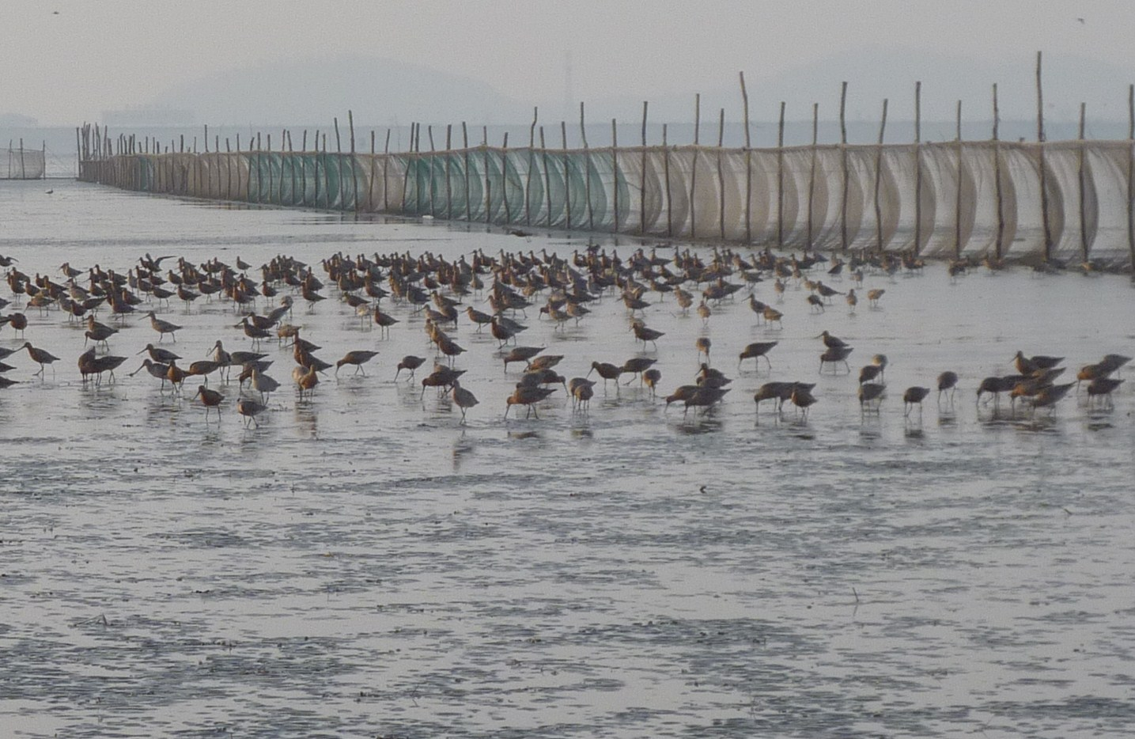
Our visit to the Reserve was facilitated by Mr Bai and I thank him. A special thanks also to Hebo Peng, whose kindness and help during our stay was greatly appreciated.

See edition 33 of Tattler, AWSG’s newsletter for my report on the surveys.

Fact Filler
- Many migratory shorebirds travel a round trip each year of 25,000km (between Australia and their breeding grounds in the northern hemisphere).
- During a 20 year lifetime, a long distance migrating shorebird would travel over 400,000 km! Long-distance migration involves flights of 4,000 km and more - sometimes up to 8,000 km non-stop.
- Flocks of shorebirds fly by day and night, over land and sea at altitudes of around 3,000 to 8,000 metres. They can adjust their altitude to avoid strong winds and take advantage of tail winds.
- Shorebirds fly at speeds of approximately 30 to 60 km/h.

Five Hundred Wrybill with a Single Catch
June 24, 2014 · Posted by Miranda Shorebird Centre

Wrybill is a very naive bird. It evolved in New Zealand when there were no introduced mammalian predators and consequently it has no appropriate behaviour to respond to the threats of predation. It is not the least bit shy when it comes to human beings either. When it comes to cannon netting this is a good feature! At Pukorokoro Miranda a significant proportion of the New Zealand, and also the world population overwinters. Other northern harbours, particularly the Manukau have overwintering populations. The birds arrive at Pukorokoro Miranda when the South Island breeding season is complete, around Christmas time. There are always non-breeding birds present at Pukorokoro Miranda any time you visit.
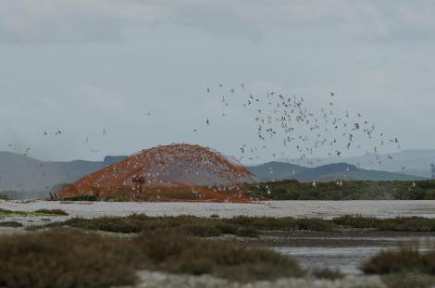
With this catch approximately 10% of the world population were trapped. © Bartek Wypych

It is in the South Island breeding sites that the species is at greatest threat. Braided river systems carry water from the mountains and, at low flow braids of flowing water are separated by large areas of rocks and gravel derived from the Southern Alps. These areas are where the bird breeds and it is ideally camouflaged to avoid visual detection. Ideally peak flow events prevent vegetation becoming established. Mammalian predators hiding in this vegetation are the major threat to nesting birds, second to this 4WD vehicles using the wide expanses for recreation.
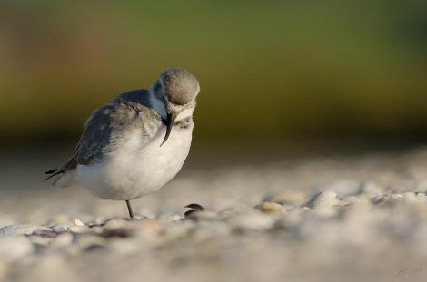
The Wrybill with laterally-curved bill specialized to feed on insect larvae under riverbed stones
© Bartek Wypych
Controlled water flows resulting from hydro schemes and reduced flow due to water extraction result in conditions that cause vegetation build up. Some rivers do still remain where the scouring effects of seasonal flood events keep the braided rivers in peak condition. However, this is a species that now depends upon human management for its long term survival.

The Remarkable Odyssey of a Semipalmated Sandpiper
Posted on: July 9, 2014 from Shorebird Science Author: Stephen Brown

Just a few days ago, Brad Winn and Shiloh Schulte returned from Coats Island with the first two geolocators from the Semipalmated Sandpiper migration study. We were waiting breathlessly to see what mysteries would be revealed! Ron Porter, who is working on analyzing the geolocator data, downloaded and analyzed the data from the first geolocator over the weekend. He produced the map below, which reveals a remarkable odyssey for a tiny bird, the first glimpse ever into the entire migratory pathway of this species.

The Semipalmated Sandpiper geolocator project was designed to solve one of the most pressing mysteries in shorebird conservation. Surveys conducted by the New Jersey Audubon Society have shown an 80% decline over the past 20 years in numbers within the core wintering range in northern South America. At the same time, data from the Arctic show that breeding populations are apparently stable at some sites, especially in the western part of the arctic breeding range in Alaska. We need to understand the migratory pathways of the species in order to know where the decline is occurring, and what can be done to reverse it. Light-level geolocators are a cutting edge technology and their use has helped revolutionize our understanding of shorebird migration, but they have never been used on Semipalmated Sandpipers before this project.

Manomet has partnered with biologists from many organizations, including the U.S. Fish and Wildlife Service, New Jersey Audubon, Kansas State University, the Wildlife Conservation Society, the Canadian Wildlife Service, Simon Fraser University, the Government of Nunavut, and Université de Moncton to coordinate the first effort to use geolocators to understand the migratory pathways of this species.

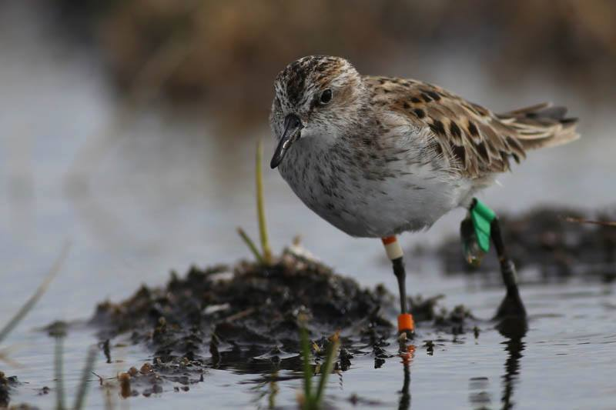
Semipalmated Sandpiper number 254, just before it was recaptured. After sharing its journey with us by carrying the geolocator, it is now getting ready to head out on its next journey back to its wintering area in Brazil.

Analysis of the data from the geolocators is key to understanding what the tiny units have recorded during the past year. The map below shows the first ever track of an entire year in the life of a Semipalmated Sandpiper from the eastern Arctic, the group for which the decline may be particularly severe. This particular bird, a male, flew a total distance of over 10,000 miles in the past year. He also made a remarkable six day, 3,300-mile nonstop flight across the Atlantic Ocean from James Bay to South America, before moving on to his wintering area in Brazil.

The second geolocator that was recovered at Coats Island had lost battery power, a common occurrence, so it had to be sent back to the company that manufactured it in England to download the data. It should still have recorded much of the journey of the bird it was attached to, and we are excited to learn how its journey may have been similar or different from this one.

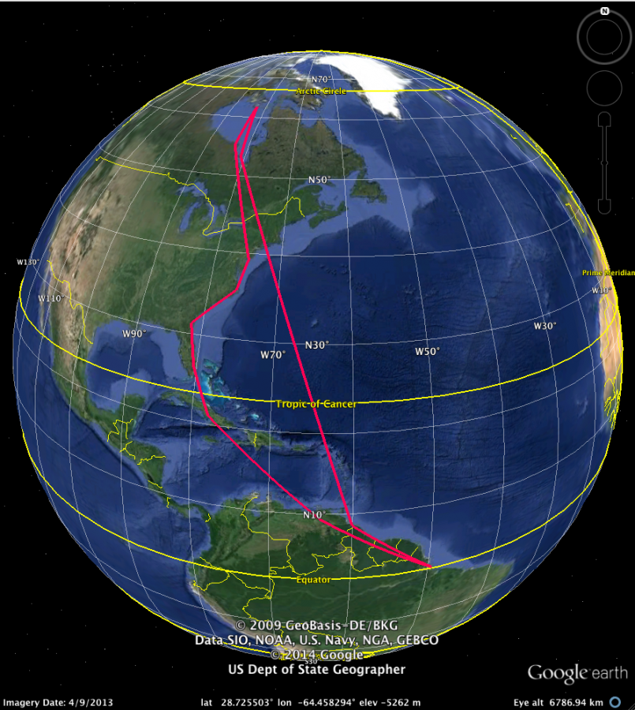

At the same time, at least 35 other units have been recovered in Alaska. These units are on their way back to Anchorage and will be sent on to Ron for analysis. We will learn an enormous amount from those as well, in particular whether the western arctic birds also winter in the same areas in South America where the aerial surveys have shown the dramatic decline. We will share results here as soon as they become available.

We are very grateful to our partners from Environment Canada, who supported our travel back to Coats Island and who have worked with us closely on the fieldwork for this project. We are also very grateful to the supporters who helped make this project happen. Without their commitment to shorebird science, none of this would be possible. We hope you all enjoy this glimpse into a previously unknown world, the timing and flight path of an entire year in the life of a Semipalmated Sandpiper.

Here are the highlights from its journey:
23 June, 2013. The geolocator is placed on the bird by Brad Winn, a member of a Manomet shorebird science research team, at Coats Island, Nunavut, Canada.
21 July, 2013. Arrives in James Bay, where it fattens up for its upcoming long flight to South America.
22 August, 2013. Leaves James Bay for a six day nonstop flight to South America.
28 August, 2013. Arrives at the Orinoco Delta, on the border of Venezuela and Guyana.
10 September, 2013. Leaves for a relatively leisurely 11 day flight along the coast to Brazil.
21 September, 2013. Arrives in Brazil for the winter (northern winter, but summer in Brazil).
3 May, 2014. Leaves Brazil for a series of flights north, including stops in Cuba (May 6), Florida (May 10), Georgia (May 11), North Carolina (May 14), and Delaware Bay (May 21).
2 June, 2014. Arrives back in James Bay for the last stopover on its return journey.
10 June, 2014. Leaves James Bay for the final leg of its return journey.
11 June, 2014. Arrives back at its Coats Island breeding site.
18 June, 2014. The bird was re-captured by Brad Winn and Shiloh Schulte, its geolocator was removed, and it was released to begin its next odyssey!

Fact Filler
Shorebirds live a long time: large birds up to 30 years, medium 10-20 years, and small 4-10 years.
Mortality among adults away from the breeding grounds is low: 70-95% of adult birds usually return to breed.

First hand-reared spoon-billed sandpiper returns to breed
25 Jun 2014 by Saving the Spoon-billed Sandpiper

The first hand-reared spoon-billed sandpiper has returned to breed in Chukotka, Russia, where it was hatched two years ago.

The spoon-billed sandpiper is unique in the animal kingdom for being born with a spoon-shaped beak. Numbers have declined by a quarter year on year and it is likely that fewer than 100 pairs remain in the wild. WWT aviculturist Roland Digby has reared 24 spoon-billed sandpipers over the last two summers on their breeding grounds in north eastern Russia, giving them a head start to ensure they survived their crucial first days of life.

Once released, the birds migrated 5,000 miles to south Asia, facing exhaustion, starvation and illegal hunting along the way. There has been a two year wait to see if any will survive to return to breed. Now one of the group has been seen back at its birthplace by researchers from Birds Russia, Pavel Tomkovich and Egor Loktionov. They reported that the bird is looking heavy, indicating that she is a female carrying eggs and ready to breed for the first time. After two years she could become the first hand-reared spoon-billed sandpiper to produce offspring in the wild and add to the species’ fragile population.

WWT aviculturist Roland Digby said:
“The incredible spoon-billed sandpiper is no bigger than a sparrow, yet it flies almost half way round the world before it’s even old enough to breed. Sadly, very few make it. There are probably fewer than 100 breeding pairs left in the wild, so every bird that reaches maturity represents new hope for the species”.

The hand-rearing is an attempt to stabilise the species’ population before it becomes extinct. Rearing and releasing birds on the breeding grounds increases the number of young birds in the wild in autumn by about 25%. Meanwhile conservationists are tackling the illegal hunting and habitat loss that is behind the decline.

Pavel Tomkovich of Birds Russia said:
“Two years ago I attached a tiny plastic leg flag to this bird, so that we’d recognise it if it was ever seen again. The odds were severely stacked against that happening, but amazingly she was spotted, first by birdwatchers in Taiwan in April and then we see her here at her birthplace ready to have young of her own.”

The bird hatched on 14 July 2012 from an egg of a clutch collected for artificial incubation on 22 June. After fledging it was released on 10 August and was last seen on the Russian breeding grounds on 17 August 2012. The next sighting was on 7 April 2014 by Chung-Yu Chiang and Chin-Shi Hsu at Kinmen Island, Taiwan, on the edge of the tropics. She was subsequently seen by Pavel Tomkovich and Egor Loktionov near Meinypilgyno, on the edge of the Arctic Circle on 18 June.
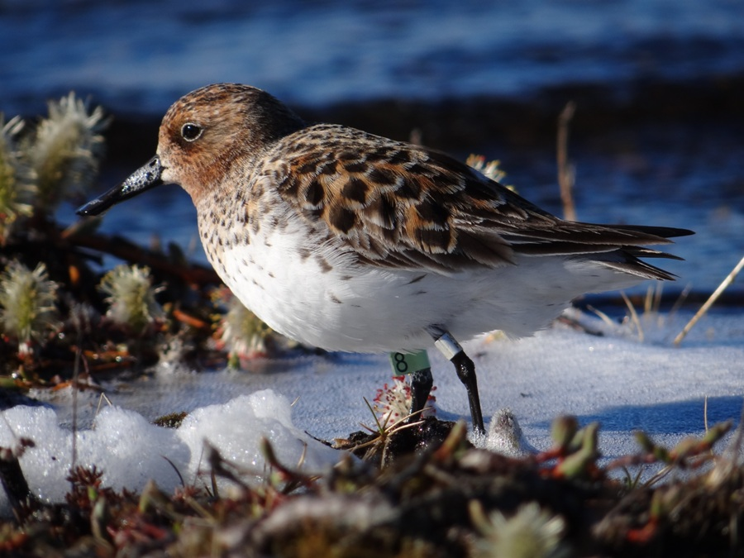

Norbert Schäffer, the RSPB’s head of international species recovery, said:
“It’s great to see parts of the plan to protect this precious species coming together, but it’s a long road and there is still a lot more to do in terms of tackling the problems on the flyway. This is a huge international effort involving many different partners and with everyone doing their bit.”

Dr Nigel Clark of BTO and the UK Spoon-billed Sandpiper Support Team said:
“This is the first proof that hand-rearing works and that these birds behave and migrate normally. We had predicted that it would work, based on studies on other migratory waders, but we couldn’t be sure that spoon-billed sandpipers would behave the same way. Over the next few years these individually marked birds will help us to understand how best to bring the species back from the brink of extinction.”

The project is part of a multi-pronged international attempt to save the spoon-billed sandpiper. In case the birds in the wild suffer further losses, the only reserve flock in the world is being reared in a biosecure facility at WWT Slimbridge Wetland Centre. In the near future, eggs from the Slimbridge flock could be flown to Russia to be hatched and released as an insurance against the species falling into extinction quicker than it can be saved in the wild.

The spoon-billed sandpiper conservation breeding programme is a collaboration between WWT, Birds Russia, Moscow Zoo and the RSPB working with colleagues from the BTO, BirdLife International, ArcCona and the Spoon-billed Sandpiper Task Force.

Surveys! Surveys! Surveys! – Calling all counters

In mid-2013, the QWSG applied for a Friends of Parks grant to fund our biannual survey of high tide roosts in the Great Sandy Strait (GSS). This grant was planned to support the proposed survey in December 2013. However, the outcome of the grant application was not announced until after we made the survey on the weekend of 7 – 8 December 2013. QWSG was successful in obtaining a grant for approximately $6,700 to fund the survey. We now have to make another survey of the Great Sandy Strait before the grant completion date on 31 December 2014.

For the last six years, QWSG have made surveys of the Mackay – Whitsunday coast during the alternate years between surveys of GSS. Thus, the biannual survey to Mackay is due this year.

QWSG committee have decided to undertake surveys of both GSS and Mackay in 2014. All members and interested wader counters are welcome to participate in either or BOTH surveys. The proposed dates for each survey have been identified based on the best tides available during the summer that do not clash with our regular monthly counts.

The proposed dates are as follows:
Great Sandy Strait survey: 11 – 12 October, 2014 – Interested participants please contact David Milton
for details.
Mackay survey: 8 – 9 November, 2014 - Interested participants please contact Peter Driscoll for details.

Accommodation and transport costs during both surveys will be provided by QWSG. For the GSS survey, vehicle fuel costs travelling to and from the survey will also be reimbursed. In Mackay, air flights and most food costs will also be covered for participants. We need about 14 counters to undertake each survey efficiently, but always appreciate more counters if interested. Both surveys are suitable for new and experienced members with a telescope and provide great opportunities to learn about wader id and visit interesting parts of the Queensland coast.
David Milton

Fact Filler
- Shorebirds need to eat up to one-third their body weight every day to fuel their active lifestyle as well as build up fat reserves for their long migrations. In some, fat reserves can make up to 30% of their body weight.

Geolocator
From Wikipedia, the free encyclopedia

Although the word 'geolocator' is non-specific, this is often used to describe a device that primarily and periodically records ambient light level (solar irradiance) to determine location. A geolocator, light-level logger, GLS or bird logger is essentially a lightweight, electronic archival tracking device, usually used in bird migration research to map migration routes, identify important staging areas, and sometimes provide additional ecological information.

History
Animal tracking using light level data appears to have been first carried out on elephant seals. Although not described until 1992, the first device to be developed was reportedly in 1989 as an adaptation of a TDR (time-depth recorder) and called a geographic location, time-depth recorder (GLTDR) weighing 196g. Also in 1992 was a publication by a different group with a similar design (weight 113g) who called it a global location sensor (GLS) though no field use was mentioned.

The use of dedicated light level recorders for tracking birds was pioneered in the 1990s by engineers and scientists at the British Antarctic Survey (BAS) which first developed a device in an attempt to record the movements of juvenile Wandering Albatross during the many years between fledging and returning to their colony to breed. From albatrosses and other seabirds the use of geolocators has been extended to other migratory species, including waders, wildfowl, raptors and songbirds as designs have become gradually smaller and more energy efficient.

Methods
Geolocators record changes in light levels. The smallest are archival types that do not use satellite or radio telemetry and recapturing the bird is necessary to retrieve the device to download the data to a computer for analysis. The disadvantage of having to recapture is offset by the miniature size to which archival loggers can be made. By using low power design techniques and data compression they can record data for long periods of time.

Recording light levels over time produces data that can be used to calculate latitude and longitude readings of a bird’s long-distance movements. The traditionally used 'threshold analysis method' requires only twilight data accurately time-stamped. Typically, daylight length (the time between dawn and dusk) is used to determine latitude, while the mid-time between a dawn and dusk is used to determine longitude. In this way, two position fixes can be obtained daily. Other analysis techniques can include analysis of the dawn and dusk curve (rate of change of light), or use the noon light level to attempt cloud compensation. The location data so derived is not as accurate as that from GPS or PTT (platform transmitter terminal) tracking involving satellites, but the devices can be made considerably lighter and cheaper.

Other sensors, such as for recording temperature, or whether the logger is wet or dry, may be used in conjunction with the light-level logging in order to provide further ecological information. The devices may be attached to the bird being tracked by a harness, or to the band on the bird’s leg. The weights of geolocators range from about 0.6g to 2.5g, with a battery life of 1–5 years.

The main accuracy limitation of light level geolocation is due to the uncertainty caused by shading. Shading, or the attenuation of ambient light, can have many causes e.g. cloud, feathers, foliage. Because of this, the quality of the resulting location calculations can vary with species, habitat and behaviour.

Advance Notice of AGM and QWSG Rules Update

QWSG have recently updated their rules of operation, which can be seen on the ‘downloads’ page of the web site, www.waders.org.au, notice is given that at our AGM we will propose to endorse and accept these rules.

The 2014/15 AGM will be held at 10:00am on the 14th December 2014 in Greene Park Wynnum, before the Port count, please see the news page of the web site for details, or contact Jon Coleman at Chairperson@waders.org.au if you want to attend or comment on the rules prior to the meeting.

WADER WATCH Phil Cross

Can everyone please remember to use the ‘Leg Flag Observation Report’ form?

Can we also please ask people to carefully check which leg the flag is on? If you are not sure, or just see the colour, and do not know which leg it is, please do not make it up. We do record the sighting on the database, even if we do not know which leg it was on. Recording information that you have not seen, or do not know creates extra work for Phil and other people who this information goes to. We would appreciate your cooperation on this issue.

Green leg flag sightings

In each Qld Wader issue, there are quite a number of green leg flag sightings recorded within Moreton Bay, which is where the bird was banded originally. As we are now seeing more leg flag combinations from other states and countries, and have limited space available for sightings, we will not be listing each individual sighting of green flag records in Queensland unless there is a significant movement of the bird. Instead, we will list the number of flags for each species and the period in which they were seen.

Sightings in Moreton Bay & Environs totalled 90 between 30.01.14 and 02.08.14. They were sighted by Diane Blewett, Greg Clancy, Tony Cotter, Ian Craigie, Linda Cross, Phil Cross, Detlef Davies, Kiran Dhanjal-Adams, Eduardo Gallo-Cajiao, Arthur Keates, Sheryl Keates, Chris Martinez, Jeremy Ringma, Ayesha Tulloch, and Dez Wells:
1 Eastern Curlew, 42 Bar-tailed Godwit, 25 Pied Oystercatcher, 3 Black-winged Stilt, 4 Great Knot, 1 Grey-tailed Tattler, 1 Terek Sandpiper, 5 Sharp-tailed Sandpiper, 5 Curlew Sandpiper, and 4 Red-necked Stint.

The birds sighted above included some of the individually marked flags that QWSG have been fitting and are listed below:
Bar-tailed Godwit – BC, JE, PM, AAB, ABJ, ACC, ACJ, ADD, AHT, AKV, ALV, ANP, APP, ARC, ASE, AVM, AVS, AYH, BAC, BAD, BCA, BCY, BCZ, BKJ, BNA, BNH, BPT.
Pied Oystercatcher – A7, B7, AAE, AAH, AAK, AAT, AAU, AAX, AAY, AAZ, ABB, ABC, ABE.
Black-winged Stilt – BB, AAR, BWJ.
Great Knot – NA, AAN, AAP.
Terek Sandpiper – ALE.
Sharp-tailed Sandpiper – ACB, AEL, AEM, ALM.
Curlew Sandpiper – ABP, ACK, APD.
Red-necked Stint – ZA, ZF.

Interstate & overseas Green leg flag sightings
All sightings notified to database since the previous newsletter.

1 Bar-tailed Godwit (AYD on flag) – Aphae Island (north), South Korea – Andreas Kim – 18.05.14
1 Bar-tailed Godwit – (AKB on flag) – Lian Yun Gang (Qing he River Mouth) China – Li Jing – 18.05.14
1 Bar-tailed Godwit – Songdo Mudflat, Incheon, South Korea – Judit Szabo – 15.05.14
1 Bar-tailed Godwit (BPP on flag) – Mouth of Kongo River, Matsusaka Mie, Japan – IMAI Mitsumasa – 13.05.14
1 Bar-tailed Godwit (PR on flag) – Aphae Island (south), South Korea – Andreas Kim – 13.05.14 & 18.05.14
1 Bar-tailed Godwit (EC on flag) – Aphae Island (south), South Korea – Andreas Kim – 13.05.14 & 18.05.14
1 Bar-tailed Godwit (BNN on flag) – Mokpo Wetland, South Korea – Andreas Kim – 07.05.14 & 09.05.14 & 12.05.14 & 13.05.14 & 14.05.14 & 15.05.14 & 16.05.14 & 17.05.14
1 Bar-tailed Godwit – Guangli-Zima Rivers Mouth, China – Ying Chen – 03.05.14
1 Bar-tailed Godwit (ASL on flag) – Yalu Jiang Nature Reserve, Liaoning, China – Arthur Keates & Hebo Peng – 01.05.14
1 Bar-tailed Godwit (AVK on flag) – Yalu Jiang Site 2, China – BAI Qing Quan – 28.04.14
1 Bar-tailed Godwit (BNK on flag) – Yalu Jiang Site 5, China – BAI Qing Quan – 25.04.14
1 Bar-tailed Godwit – Songdo Mudflat, Incheon, South Korea – Nam Seon Jeong – 20.04.14 & 28.04.14
1 Bar-tailed Godwit – Shuangtaizihekou Nature Reserve, Liaoning, China – Zhang Ming – 20.04.14
1 Bar-tailed Godwit (ANK on flag) – Hasaki Beach, Hasaki-shi, Ibaraki, Japan – Sugiyama Yoshiko – 20.04.14
1 Bar-tailed Godwit (AAH on flag) – Yalu Jiang Site 5, China – BAI Qing Quan – 13.04.14
1 Bar-tailed Godwit – Motueka Sandspit, Nelson, South Island, New Zealand – Ingrid Hutzler – 03.03.14
2 Bar-tailed Godwit – Motueka Sandspit, Nelson, South Island, New Zealand – Jesse Conklin – 10.02.14

1 Bar-tailed Godwit – Miranda Firth of Thames, South Auckland, North Island, New Zealand – Tony Habraken – 29.01.14 & 01.01.14
1 Bar-tailed Godwit – Ohiwa Harbour, North Island, New Zealand – Tim Barnard – 05.01.14
1 Bar-tailed Godwit – Bell’s Island, Waimea Inlet, Nelson, South Island, New Zealand – Peter Field – 23.11.13
1 Bar-tailed Godwit (ACE on flag) – Kowhai Beach, Hohoura, North Island, New Zealand – Steve Wood – 01.03.13
1 Bar-tailed Godwit – Motueka Sandspit, Nelson, South Island, New Zealand – Rob Schuckard – 13.01.13
1 Bar-tailed Godwit – Tasman Bay, Marahou, South Island, New Zealand – Rob Schuckard – 14.12.12
1 Bar-tailed Godwit – Farewell Spit (Lagoon to Lighthouse) – South Island, New Zealand – Steve Wood – 17.11.12
1 Bar-tailed Godwit (HC on flag) – Motueka Sandspit, Nelson, South Island, New Zealand – Rob Schuckard – 16.11.12
1 Great Knot – Dongling Rudong, Jiangsu Province, China – Guy Anderson – 30.04.14
1 Great Knot (BCC on flag) – Han-Bou (Han-Pao), ChangHwa county, Taiwan – Chung-Yu Chiang – 13.04.13
1 Ruddy Turnstone (EY on flag) – Mokpo Wetland, South Korea – Andreas Kim – 13 & 14.05.14
1 Grey-tailed Tattler (KZ on flag) – Zaimokuza, Kamakura-shi, Kanagawa-ken, Japan – Ike Hideo – 11.05.14
1 Grey-tailed Tattler (ASH on flag) – Tijimae Tidal Flat, Nahoya-shi, Aichi-ken, Japan – Ohta Tsuguo – 11.05.14
1 Grey-tailed Tattler (JU on flag) – Sone-machi, Matsusaka-shi, Mie-ken, Japan- Tanaka Yoko – 10.05.14
1 Grey-tailed Tattler (ARE on flag) – Mouth of Kongo River, Matsusaka Mie, Japan – Tanaka Yoko – 07.05.14
1 Grey-tailed Tattler (ABB on flag) – Mouth of Tama River, Kawasaki, Kanagawa, Japan – Sumatu Naotsugu – 04.05.14
1 Greater Sand Plover – Han-Bou, (Han-Pao), ChangHwa County, Taiwan – I-Cheng Chen – 04.04.13
1 Greater Sand Plover (BR on flag) – Fubou, ChangHua County, Taiwan – Stan Ho – 09.05.12
1 Greater Sand Plover – Han-Pao, Changhua County, Taiwan – Chih-Hui Liu – 06.04.12
1 Curlew Sandpiper – Han-Bou (Han-Pao), ChangHwa County, Taiwan – Chung-Yu Chiang – 02.15.14
1 Curlew Sandpiper (ACS on flag) – Tainan county, Taiwan – Jui-Lin Chen – 15.08.13
1 Curlew Sandpiper – Tainan County, Taiwan – Jui-Lin Chen – 11.08.13
1 Curlew Sandpiper (CM on flag) – non-specific site, Taiwan – Chih Wen-Jay – 10.04.13

Orange (Victoria) leg flag sightings
1 Whimbrel – Shellgrit Creek entrance, Mackay – Gerry Woodruff & Barry Heinrich – 17.05.14 & 12.07.14
1 Bar-tailed Godwit (ADY on flag) – Maaroom, Great Sandy Strait – Chris Barnes – 14.08.14
1 Bar-tailed Godwit (ADY on flag) – Maaroom, Great Sandy Strait – John Bell & Bill Price – 12.07.14
1 Bar-tailed Godwit (ADY on flag) – Maaroom, Great Sandy Strait – John Bell – 14.06.14
1 Bar-tailed Godwit – Queen’s Esplanade Thorneside – Kiran Dhanjal-Adams – 07.03.14

White (New Zealand) leg flag sightings
1 Bar-tailed Godwit – Norman Point, Tin Can Bay – Kelvin & Amelia Nielson – 18.05.14

Blue (Japanese) leg flag sightings – use four combinations
1 Bar-tailed Godwit with blue flag left tibia and orange flag left tarsus (both flags cut diagonally) – Toorbul – Dez Wells – 14.06.14 (flagged in Kyusu, Japan)

Black over white or white over black (Shanghai, China) leg flag sightings
1 Great Knot – Maaroom – Chris Barnes – 14.08.14

Green over orange (Yalu Jiang Nature Reserve, China) leg flag sightings
No sightings

Other wader leg flag sightings
No sightings

Pied Oystercatcher 2 digit Yellow leg flag sightings
The following sightings of yellow flagged oystercatchers are not birds flagged in North West Western Australia, as per the flagging protocol. They are another project being run from Victoria and New South Wales. Birds flagged in Victoria will have a yellow flag on the right tibia and inscribed with two digits. New South Wales birds will have the yellow flag on the left tibia and inscribed with two digits.
K3 on flag – Wynnum Esplanade – Tony Cotter – 12.07.14 & 27.07.14

Other leg flag sightings and banded birds
1 Caspian Tern – orange flag (24 on flag) – Buckley’s Hole sandbar – Greg Clancy – 21.07.14

1 Caspian Tern – orange flag – Toorbul – Phil & Linda Cross – 30.06.14
1 Caspian Tern – orange flag – Kakadu roost, Bribie Island – Michael Strong – 15.06.14
1 Caspian Tern – orange flag (C1 on flag) – Toorbul – Dez Wells – 17.05.14
1 Caspian Tern – orange flag (37 on flag) – Toorbul – Dez Wells – 17.05.14
1 Gull-billed Tern – green flag – Buckley’s Hole sandbar – Greg Clancy – 21.07.14

Not waders but of interest anyway
1 Black-necked Stork – Garnett’s Lagoon, Hervey Bay – 12.07.14
1 Black-necked Stork – Endeavour River claypan, Cooktown – 13.06.14
8 Brolga – Kinka Wetlands, Yeppoon – 12.07.14
1 Glossy Ibis – Maaroom – 14.06.14 (First time ever recorded at the roost)
6 Glossy Ibis – Luggage Point – 17.05.14
8 Australasian Shoveler – Kinka Wetlands, Yeppoon – 12.07.14
2 Radjah Shelduck – Kinka Wetlands, Yeppoon – 12.07.14
669 Grey Teal – Kinka Wetlands, Yeppoon – 12.07.14
566 Chestnut Teal – Port of Brisbane Artificial Roost – 15.06.14
467 Hardhead – permit area of Postman’s Track, Lake Samsonvale – 08.06.14
94 Pink-eared Duck – Fisherman Island Visitor Centre (Port Lake) – 13.07.14
716 Little Black Cormorant –Fisherman Island (Port of Brisbane) – 13.07.14
47 Eastern Great Egret – Port of Brisbane Artificial Roost – 15.06.14
1 Little Eagle – Bundaberg Port – 18.05.14
1 Brown Booby – Shellgrit Creek entrance, Mackay – 12.07.14
87 Great-crested Grebe – permit area of Postman’s Track, Lake Samsonvale – 08.06.14
2,830 Crested Tern – Noosa River sandbanks – 04.08.14
175 Royal Spoonbill – Fisherman Island Visitors Centre (Port Lake) – 15.06.14
1 Yellow-billed Spoonbill – Kinka Wetlands, Yeppoon – 12.07.14
1 White-necked Heron – Kinka Wetlands, Yeppoon – 12.07.14
3 Eastern Reef Egret – Port of Brisbane Artificial Roost – 15.06.14
1 Spotless Crake – Fisherman Island Visitors Centre (Port Lake) – 13.07.14
1 Gull-billed Tern (race affinis) – Toorbul – 12.07.14 (this bird has been seen at Toorbul and locations on Bribie Island for a few months)
60 White-faced Herons – Trute’s Bay Tweed Heads 23.07.14

RETIREMENT OF COUNT DATA PROCESSOR AND CHECKER
With the start of online entries for count data, the roles of entering and checking count data in QWSG’s database, previously held by Joyce Harding and Vicki Campbell, are no longer needed.

Joyce stepped into the role of entering the data from your counts soon after I became Count Coordinator in March 1997. For over 17 years, Joyce has diligently entered every piece of information from your count sheets (including all that was written in your comments box, which at times was quite lengthy).

As Joyce and I basically worked as a team, I would like to personally thank her for the tremendous effort she has achieved in getting all information into our database and for catering to my requests as soon as I contacted her to check something from counts, I sent her. Along with all the monthly counts, Joyce also entered up to an additional 50 count sheets each time we did surveys of Great Sandy Strait, Mackay, and other regions. I am sure it must have been a tedious job at times and Joyce is to be commended for doing this job for such a long time.

Vicki has had the role of cross checking the data after it has been entered into the database for three years. Along with the print-out of the data, Vicki would receive all the count sheets and physically check every entry from the count sheet to the print-out. If any errors were found she would write a list for the Data Manager to address. Vicki’s role will finish soon, when she has checked the last six months of count sheets.

Its people like Joyce and Vicki working in the background that pull the group together and make it run smoothly. Without people like them, QWSG would not be what it is today.

It was my push to get online entry to fruition that has forced them into retirement but I am sure they won’t think too badly of me while they now relax and enjoy some extra time in their lives.

On behalf of QWSG, thank you both sincerely for your dedicated commitment to the group.
Linda Cross

Count Programme
by Linda Cross

Late autumn and winter counts are not very interesting normally (apart from our resident and cross Tasman waders), but there have been some surprises on the counts sheets that have arrived recently.

An Asian Dowitcher has overwintered at the main Toorbul roost and been recorded a few times since June. The bird has slight breeding plumage and was still present during the 12 July count. Two Red Knot have also been recorded at the same roost during the winter period, with both having slight breeding plumage on their breasts.

Two Red Knot were also recorded at Mathieson Homestead, Hervey Bay on the 12 July count.

A number of QWSG counters travel to Moreton Island to conduct seasonal counts at a number of known roosts on the island itself, and in the area. The winter count took place on 14 July and there were some surprising species and numbers recorded for this time of year (particularly the Sanderling and Grey Plover). Some of the interesting species and numbers are below.

Sandbank off Amity Point Reeder’s Point Moreton Island
1,200 Bar-tailed Godwit 3 Beach Stone-curlew
70 Double-banded Plover 40 Double-banded Plover
40 Sanderling 210 Red-necked Stint
4 Grey Plover
6 Lesser Crested Tern
1,600 Pied Cormorant

At Day’s Gutter on Moreton Island 18 Grey Plover were recorded and three Beach-Stone-curlew seen at Mirapool Lagoon.

Gerry Woodruff and his team of counters recorded five Sanderling at Shellgrit Creek entrance in Mackay on 17 May, with one still being present on the 12 July count. On 27 March one Sanderling was recorded by Ken Cowell and Floss Wainwright at Pioneer River mouth north bank, Mackay. Ken and Floss also counted 54 Bush Stone-curlew scattered around in Seaforth town, north of Mackay on 2 April.

Here are a few other interesting records taken from count sheets.

2 Grey Plover – Luggage Point – 17 May 6 Marsh Sandpiper – Kianawah Wetlands – 13 May
20 Terek Sandpiper – Maaroom – 17 May 458 Red-necked Stint – Luggage Point – 17 May
8 Black-tailed Godwit – Maaroom – 14 June 9 Common Greenshank – Maaroom – 12 July
462 Grey-tailed Tattler – Fisherman Island – 13 July 22 Ruddy Turnstone – Fisherman Island – 13 July
110 Australian Pied Oystercatcher – St. Helen’s Beach, north of Mackay – 12 July

Our cross Tasman visitors (Double-banded Plover) have been recorded at 23 sites during the last few months with the highest total being 70 at the sandbank off Amity Point, followed by 47 at Geoff Skinner Reserve east, 40 at Reeder’s Point, 40 at King Street mudflats in Thornlands, 39 at Manly Harbour, 28 at Wave Break Island on the Gold Coast and 28 at Garnett’s Lagoons in Hervey Bay. Numbers at other sites were much smaller.

Resident nomadic wader species have been plentiful, but perhaps not in large numbers as in previous times.

Black-winged Stilt appeared at 10 sites, with the highest total being 490 at Luggage Point on 17 May, followed by 470 at Maaroom on 14 June and 373 at Toorbul sandspit on 14 June. Numbers at other sites have been significantly lower.

Red-necked Avocet were recorded at only seven sites and the highest total came from Fisherman Island (Port of Brisbane) with 302 on 13 July, followed by 154 at Trute’s Bay, Tweed Heads on 23 July, 147 at Luggage Point on 12 July and 93 at Deception Bay south on 12 July. Numbers at other sites were less than 20.

Red-need Dotterel were sighted at seven sites in low numbers, and 17 was the highest total recorded at Luggage Point on 12 July, followed by 10 at Garnett’s Lagoons in Hervey Bay on the same day.

Black-fronted Dotterel appeared at 13 sites, with the highest total being 25 at Luggage Point on 12 July.

I must admit to not mentioning our other resident waders and apologies for not including them in the count programme as often as I should because it is just as important to be concerned about their welfare too.

Records from count sheets for Beach Stone-curlew show them appearing at nine sites. In the listing below I have not included the birds seen on Moreton Island, which appear earlier in this article:
4 – Goat Island Maroochy River – 21 May & 21 July
3 – Kakadu Beach roost, Bribie Island – 16 June & 2 on 1 June
2 – Caloundra Bar – 12 July
2 – Noosa River sandbanks – 18 July & 19 June
2 – Wave Break Island, Gold Coat on 25 July
1 – Shellgrit Creek entrance, Mackay on 12 July

Sooty Oystercatcher were observed at nine sites from March through to July as follows:-
5 – Gable’s Point Rocks, Hervey Bay – 20 May 4 – Wickham Point – 17 May
4 – St. Helen’s Beach, north of Mackay – 27 May 2 – Finlayson’s Point, north of Mackay – 16 May
1 – Shellgrit creek entrance, Mackay – 17 May 1 – Maroochy River north shore – 19 June

The only large total for Red-capped Plover came from O’Regans Creek Westside, Hervey Bay where 79 were recorded on 17 May and 78 still at the site on 12 July.

There are no autumn/winter records for Wandering Tattler.

Although not waders, Sue Sargent and her large team of counters covering the Port of Bundaberg site had an exceptional list of raptors on their June count. In total 12 species were seen, which included Eastern Osprey, White-bellied Sea-Eagle, Black-shouldered Kite, Brahminy Kite, Whistling Kite, Black Kite, Brown Falcon, Nankeen Kestrel, Pacific Baza, Australian Hobby, Peregrine Falcon and Spotted Harrier.

Four breeding records as follows:-
Pied Oystercatcher – one nesting at Kakadu Beach roost, Bribie Island – 03.08.14
Black-winged Stilt – three young at Port of Bundaberg – 13.07.14
Comb-crested Jacana – four chicks at Buckley’s Hole, Bribie Island – 25.05.14
Red-capped Plover – two runners at Seaforth Beach creek mouth, north of Mackay – 02.04.14

Spring (and hopefully some of the migratory waders) will have arrived by the time you receive this newsletter, so it’s time to give your scope and binoculars a good clean to enable you to see the variety of different plumages. I have seen a note on one of the birding websites that a Latham’s Snipe has been seen at Sandgate on 12 July. This is one of the species (along with Eastern Curlew), that arrive back first.

It would be great if counters could record the number of juvenile birds in each flock of species, which will give us an indication on how successful they have been breeding.

I have been given a few names of people to contact who are interested in counting, and I will endeavour to contact them very shortly. In the meantime, we still need extra permanent and standby counters for the count programme and also the Port count. If you can help in any way please contact me.

Online count entry has begun.

Five counters were given their usernames, passwords and instructions to enter their July counts online. We chose a cross section of counters to trial the online entry so that we could iron out any problems that occurred during the entry. Although a few queries arose from the entries, there were only a handful of mistakes made during the process.

As I send this article to the editor the August count will have started, and you should have received your username and password so you can now enter your counts online. If you have not received them please contact me. I am hopeful that this will dramatically reduce my workload.

Leg flag sightings must not be entered online during count entry. All leg flag sightings from now on must be recorded on the Leg Flag Observation Form and sent to Phil Cross using either of the two above methods. If you do not have a copy of the above form, please contact us, and we will send it to you.

Any remaining counters that will not be entering their counts online, please continue to send counts to me at our email address as follows

Happy counting.
Linda Cross.

Wader ID Days

Sunday 14th September at Manly Harbour

2.13 metre high tide at 1.18 p.m. Meeting time 12.00 noon.

This is your chance to legally get behind the fence and check out the waders with our group. Meet at the end of the road, east of the Royal Queensland Yacht Clubhouse, Manly. UBD map 164 A6. Gates will be locked after we enter and late arrivals will not be able to access the site. Therefore, we need to know if you are planning to attend this id day. Please ensure you contact the people below and have your name put on the list. We would also like to keep the numbers at a reasonable quantity, so book early.

Please contact any of the following people if you have any questions. Arthur & Sheryl Keates or Phil & Linda Cross/

Wednesday 15th October at Toorbul

1.98 metre high tide at 2.26 p.m. (plus 30 minutes later for Toorbul – 2.56 p.m.). Meeting time 1.30 p.m. onwards.

Take the Bruce Highway north from Brisbane to the Donnybrook/Toorbul exit. Turn off here and head east over the highway overpass. Continue on this road to Toorbul. Turn right at the T-junction then first left and then right, which brings you onto the Esplanade. Follow this road to the end (approximately 2kms); we will be on the left.

Bring water, food and a chair. It is a good idea to have a hat, sunscreen and insect repellent. Most importantly bring your binoculars or telescopes. Hopefully we can provide the answers to all your questions.

Please contact any of the following people if you have any questions. Phil & Linda Cross or Arthur & Sheryl Keates.

Friday 28th November at artificial roost at the Port of Brisbane

2.30 metre high tide at 1.51 p.m. Meeting time 12.45 p.m. in the car park at the roost.

To get there, take Port Drive straight through the roundabout past the service station on the left, soon after crossing the boat passage veer right into Lucinda Drive (signed visitors centre) taking the overpass, continue past the lake on the left for almost 2 km, the car park for the roost is on the right just past Bingera Drive which is on the left.

Please note: Only Birds Qld and QWSG members who register to attend will be allowed to enter the site without making other arrangements with the Port of Brisbane Corporation.

To register attendance, please contact Arthur & Sheryl Keates.

Fact Filler
Biologists think shorebird eggs are pointed on one end so that they can fit together smoothly in the nest in a pinwheel shape. This keeps more surface of each egg covered and helps them stay warmer during incubation.

Other Conservation Activities of Interest
QWSG is a special interest group of the Birds Queensland Inc. whose object is:
“To promote the scientific study and conservation of birds by all means possible, with
particular reference to the birds of Queensland”.
Separate membership is required.
Contacts: President, Richard Noske president@birdsqueensland.org.au
Secretary, Rae Clark secretary@birdsqueensland.org.au
Treasurer, Wayne Lock treasurer@birdsqueensland.org.au

Monthly Meetings Birds Queensland
1st Thursday each month except January, when there is no meeting.
Royal Geographical Society Meeting Room, 237 Milton Road, Milton.
Arrive after 7:15pm for a 7:30pm start.

Electronic Newsletter??

Are you interested in receiving your “Queensland Wader” by email?
If you are interested email me on gouldian@ozemail.com.au or the treasurer at membership@waders.org.au Please could you use the subject line as “Electronic Newsletter”. Editor

QWSG MERCHANDISE

Should you wish to purchase any of the QWSG merchandise, Contact Vicki Campbell

Postage is not included in prices quoted.

BOOKS $35.00 Shorebirds of Australia
METAL BADGES $5.00 Metal QWSG logo badges.
CLOTH BADGES $8.00 QWSG logo on rectangular bottle-green or sand background
POLO SHIRTS $42.00.

Our cotton polo shirts are available.
The locally made shirts are plain bottle or sky
with contrast collar in sand, or tri-coloured
sand / cocoa / sky and sand / cocoa / bottle.

Men’s sizes: SM - XL

NEW MEMBERS

We welcome the following new member who have joined recently:

Ms Noleen BROWN, Mr Gary CAREY, Ms Anita FLYNN,
Mr Connor FERGUSON, Mr Eduardo GALLO-CAJIAO, Ms Marion GROVER,
Ms Mandy LISSON, Mr Rob MACKENZIE, Ms Thiruni RAMANADEN,
Ms Martha REES, Ms Cathy WILLIAMS & Ian JOHNSON

A reminder to members, please let the Treasurer know if you change your email address. If you do please make sure that it does allow delivery and not send downloads to spam.

Many thanks too to those who have included a donation with their renewal or membership fee. This is greatly appreciated as such donations make on-going work possible.

QWSG CONTACTS

QUEENSLAND WADER www.waders.org.au
The Official Quarterly Publication of
Queensland Wader Study Group

MEMBERS of the MANAGEMENT COMMITTEE of the QWSG
CHAIRPERSON: Jon Coleman
TREASURER Deirdre Chrzescijanski membership@waders.org.au
SECRETARY: Peter Rothlisberg
NEWSLETTER EDITOR: David Edwards gouldian@ozemail.com.au
COMMITTEE MEMBERS:
Robert Bush Peter Driscoll
Richard Fuller Andrew Geering
Sandra Harding Sheryl Keates
David Milton
BQ PRESIDENT Richard Noske
COUNT COORDINATOR: Linda Cross
DATA ENTRY Joyce Harding
LEG FLAG COORDINATOR Phil Cross
MERCHANDISE Vicki Campbell
CORRESPONDENCE All correspondence to:
The QWSG Chairperson,
xxxxxxx
xxxxxx
QLD xxxx
CHANGE OF ADDRESS Please notify the Treasurer as soon as possible of any change of address so that your Newsletter can be dispatched correctly.

SUBSCRIPTIONS Annual subscription rates:
Single: $15:00
Student/Pensioner: $10:00
Family $25:00
A receipt will be forwarded if required.

Forward application to:
QWSG Treasurer
PO Box 3138,
SOUTH BRISBANE,
QLD 4101

Members are reminded their membership expires on the date shown on the newsletter address label, and the membership joining/renewal form is now on the back page. Note: that your subscription will fall due twelve (12) months after date of joining the QWSG or date of renewal, and only one further newsletter will be sent after expiry of your subscription.

Copy Deadline for the next issue of Queensland Wader is November 18th 2014
Contributions should be addressed to:
David Edwards, the QWSG Editor, 54 Elliott Street, Clayfield, Qld 4011
or E-mail to: gouldian@ozemail.com.au

Opinions expressed in Queensland Wader are those of the individual contributors and are not necessarily those of the Queensland Waders Study Group, nor Birds Queensland.
Advertising Rates are $20:00 for one-quarter page and $25:00 for a third of a page.

PRINTED BY: Mr Bob Durrington of J.R. Durrington & Sons Pty Ltd.

admin@jrdsons.com.au

The QWSG WADER COURSE

An Introduction to Waders (Shorebirds) in Australia and Moreton Bay

This course offers a unique opportunity to learn about a special group of birds, waders. These birds are magnificent athletes, flying up to 25,000 km every year. They range from tiny 24-gram birds to the world’s largest wader, the Eastern Curlew, weighing in at over 1 kilogram. Moreton Bay, on Brisbane’s doorstep, is an internationally significant area for waders, but most people are oblivious to their presence.

Seventeen resident and 36 migrant species of wader occur in Australia; in total, about 3 million birds. They feed on the shorelines of coastal and inland wetlands of Australia. The majority breed in the higher latitudes of the Northern Hemisphere in places like Siberia and Alaska, and travel the East Asian/Australasian flyway twice a year on migration. From September to April, a large number of species can be found in Moreton Bay, and we have an ideal opportunity to study these species. They face increasing pressures from burgeoning human populations and habitat destruction throughout the flyway.

During this one-day course you will be introduced to these fascinating birds through specific topics that include:
- What are waders, there evolution and taxonomy;
- Field identification;
- Migration and breeding
- Importance of Moreton Bay;
- The East Asian/Australasian Flyway;
- Challenges and threats;
- National and International conservation agreements.

The field trip will give you the opportunity to have a ‘hands on’ chance to identify many of the species mentioned in the lectures with experienced wader-watchers.

THE COURSE CONSISTS OF A MORNING OF LECTURES AND AN AFTERNOON FIELD TRIP

COST: $ 50.00 . To confirm your registration, please transfer your fee using the details below. Receipts will be issued on the day of the course at registration. Places are limited so register soon and keep an eye on the website for availability.

REGISTRATION; Saturday 1st November 2014, 8.30am to 9.00am
at the Manly NPRSR Office, 34 Trafalgar Street, Manly 4179

LECTURES: 9.00 am to 1.00 pm, Morning tea and lunch included.

FIELD TRIP: Saturday 1st November, 2014, 2.00 to 4.00 pm, at Manly Marina Roost
Please note that the field site is exposed – remember to bring a hat, sunscreen and water bottle. We also recommend wearing closed shoes for the field visit.

CLOSING DATE: Please enrol by Friday 17th October 2014. Remember places are limited.

ENQUIRIES: Jon Coleman:
Website: www.waders.org.au/queensland-wader-study-group-news
email: Chairperson@waders.org.au
-------------------------------------------------------------------------------------------------------------------------------------------------

ENROLMENT FORM (email to treasurer@waders.org.au)
Course Fee: $50.00 pay by direct transfer to:
Qld Wader Study Group BSB: 313 140 Account Number: 08305297
Please use your Surname as the identifier on the transaction
Title: ……………First Name: ………………………Last Name: ……………………………………………..

Address: …………………………………………………………………………………………………………..

……………………………………………………………Email Address: ……………………….……………..

Organisation (if applicable): ………………………….Phone Number:……………………………………….
Do you require a vegetarian or other special lunch? Please specify ………………………………………

Count Activities – 2014

QWSG High Tide – Monthly Count Program – 2014
Sat 27th Sep 2.16m at 11:12
Sat 25th Oct 2.31m at 10:15
Sat 22nd Nov 2.39m at 09:16
Sat 13th Dec 2.06m at 13:44

Port of Brisbane Count Dates – 2014
Sun 28th Sep 2.14m at 11:50 Meet 10:00
Sun 26th Oct 2.32m at 10:54 Meet 09:05
Sun 23rd Nov 2.45m at 09:57 Meet 08:10
Sun 14th Dec 1.96m at 14:33 Meet 12:40
The Port of Brisbane is a work site and we are doing the survey for the Port and ourselves. Unfortunately we cannot accept people who turn up on the day for a bird watching day.

PLEASE CHECK TO SEE IF YOUR RENEWAL IS DUE!
A reminder to members to please let the Treasurer know if you change your email address.

MEMBERSHIP/RENEWAL APPLICATION

I / We wish to join / renew: (Single $15; Family $25; Student/Pensioner $10)
Title…… First name: ……………………Surname Name:…………………………………
Address:………………………………………………… Membership: $………
…………………………………… Postcode:……… Donation: $………
Payment enclosed: $________
Phone: (Home) ……….. (Work) ………….
Fax / e-mail: ………………………………………….
TOTAL $………
How did you hear about QWSG ……………………………………………………………………………….
Are you a member of Birds Queensland?.....................................
What activities do you wish to participate in? (Please circle)
WADER COUNTS, FIELD TRIPS, SCIENTIFIC DATA COLLECTION, SURVEYS, CLERICAL,
OTHER (specify………………………………………..…….)
Would you like to receive your newsletter by E-mail…………………

SIGNATURE: …………………………………………………. DATE:……………………

Please post this form to: QWSG Treasurer, PO Box 3138, SOUTH BRISBANE, QLD 4101
Cheques to be made out to: Queensland Wader Study Group

Or Direct funds transfer to:
For a direct credit, please use the following details.
Qld Wader Study Group
BSB: 313 140
Account number: 08305297

Please email this form to: treasurer@waders.org.au

